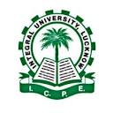

**INTEGRAL UNIVERSITY**

**DEPARTMENT OF CHEMISTRY**

**GUEST LECTURE**

**ON**

**Upper Continental Crust Composition and Geochemical Cycling of Elements: Present Challenges and Future Perspective**

14th September 2018

The Department of Chemistry, Integral University, organized a guest lecture on Upper Continental Crust Composition and Geochemical Cycling of Elements: Present Challenges and Future Perspective on 14th September 2018 in NLT-5. Dr. Anupam Sharma, Scientist F, Birbal Sahni Institute of Paleosciences, Lucknow, was the guest speaker who emphasized on the importance of composition of continental crust and geochemical cycling of elements and its need for the sustainable environment. The lecture was attended by around 90 students belonging to the Faculty of Science and 15 faculty members.

Submitted by

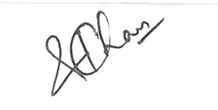

Dr Saimah Khan

Assistant Professor,

Department of Chemistry,

Integral University, Lucknow